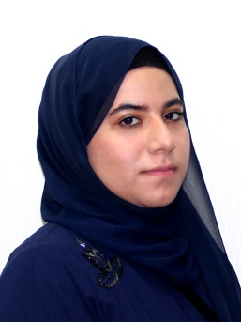**Zainab Al-Satrawi**

**PERSONAL PROFILE**

**Date of Birth:** 22 December 1996

**Nationality:** Bahraini

**Marital Status:** Single

**Mobile**: +973 36692612

**E-mail:** zainabsatrawi@outlook.com

**OBJECTIVE**

My goal is to become associated with a company where I can utilize my skills and gain further experience while enhancing the company’s productivity and reputation.

**EDUCATION**

**University of Bahrain**

B.A. IN ENGLISH LANGUAGE AND LITERATURE-Major-2012- MINOR IN TRANSLATION.

**GPA:** 3.03

**Al Hoora ,** Secondary School Certified 2011.

**EXPERIENCE**

**English Teacher ( part-time)**

**26th Sep2018-31st Oct2018 Modern Institution**

**Bahrain TV News Translator**

**June2018- Augest2018 Ministry of Information Affairs**

Worked as a translator in Bahrain TV News Center as a trainee to fulfil the requirements of the Bachelor’s degree

**KEY SKILLS**

* Fluent in both Arabic and English languages written and oral.
* Office Software’s & Windows OS.
* Good English accent.
* English/ Arabic translation.